**Web Design and Development Foundations with HTML5**

**Fill in the Missing Code**

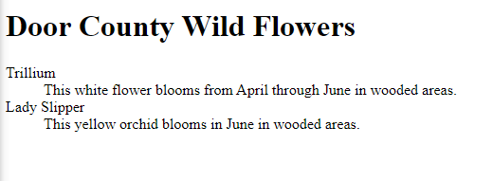

<!DOCTYPE html>

<html lang="en">

<head>

<title>Door County Wild Flowers</title>

<meta charset="utf-8">

</head>

<body>

<header><h1>Door County Wild Flowers</h1></header>

<main>

<dl>

<dt>Trillium</dt>

<dd>This white flower blooms from April through June in

wooded areas.</dd>

<dt>Lady Slipper</dt>

<dd>This yellow orchid blooms in June in wooded areas.</dd>

</dl>

</main>

</body>

</html>

**Find the Error**

**Before:**

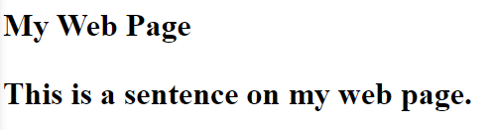

**After:**

<!DOCTYPE html>

<html lang="en">

<head>

<title>Find the Error</title>

<meta charset="utf-8">

</head>

<body>

<h1>My Web Page</h1>

<!-- All the paragraph displays in large and bold font typeface because the </h1> closing tag was missing the forward-slash. -->

<p>This is a sentence on my web page.</p>

</body>

</html>